Local Crime Reports
The list below provides a summary of recent local crimes, organised by Parish from 1st Feb to 29th Feb 2016. It is not possible to list all the crimes due to confidentially issues (e.g. if the crime was violent or for domestic disputes). No mention then no reported crime!

DINTON-

Between 10am and 1pm on 10th Feb a car was broken into whilst parked at the Drove area. Cash within was taken and damage caused to the door.

Between 12midday and 12.50pm on 11th Feb another car was broken into whilst parked at the NT car park on St Mary’s Rd. The rear window was smashed but nothing stolen – owner states there was nothing of value in it either.

CHILHAMPTON–

Overnight 22nd Feb – 23rd Feb offenders broke into a container which housed various industrial power tools to value of £10,000.

SOUTH NEWTON-

Over a period between 25th Jan – 24th Feb suspects have tried to pull the black key cover off on the drivers side door, smashed off the passenger side wing mirror leaving it in the middle of the road, then snapped the arm off the drivers side wing mirror leaving it dangling by a wire, on three separate dates.

Cont..

The below pic was taken of toe rags at a farm in Stoford – large amount of damage caused to field which had been recently drilled.

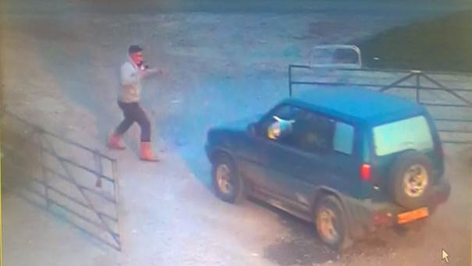

Below - white Ford Transit HK51JRZ.

From the Gillingham area – travelling across the 3 counties committing theft from farms. A farm was targeted at the end of Jan in Sturminster Newton, nothing taken but 3 males in balaclavas were seen getting into this van at that location the night before.

Spotted heading into Broadchalke on 22/2 and is routinely hitting ANPR cameras across the area.

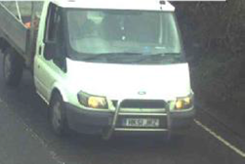note the bull bars.

**If you have information relating to any of these crimes, please contact me on 01722 438981 (non-urgent only). I am also contactable via e-mail at peter.jung@wiltshire.pnn.police.uk (again non-urgent). You can also pass information in confidence via Crimestoppers on 0800 555 111. REMEMBER IN AN EMERGENCY ALWAYS 999**

