From the Archives John Burrough

A BRIEF HISTORY OF BROAD CHALKE Congregational CHURCH
and the united reformed Church
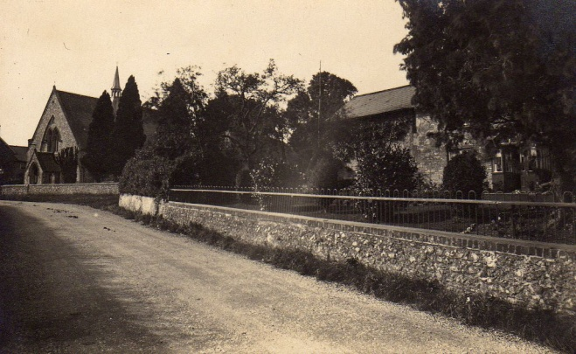
Before 1777
Mr Gould and four sons ‘in vain sought satisfaction in the offices of their own Church’.
1777
Preaching services first held in Broad Chalke in the house of Robert Fox, a furze cutter (gorse used in bread ovens) who lived in a cottage between All Saints’ Church and South Street – now the front part of the graveyard. Another house ‘temple’ was situated at Stoke Verdon. ‘A report soon spread that it was the false prophets who preached at Broadchalke’. Later services were commenced in Mr Josiah Gould’s farmhouse kitchen (believed to be in what we now know as Blick’s Yard).
High Road
1801
‘The congregation had sufficiently increased to build a house for themselves’. The old Chapel in Chapel Lane was built on part of land called “Stuckey’s” given by Mr Josiah Gould; used until 1863, named ‘The Temperance Hall’ by the 1880s and, more recently, used for a period for band practice; it is now part of Chapel Cottage.
1808
The land for the old Chapel in Chapel Lane was ‘further secured to the congregation by a Trust Deed dated January 21st 1808’ at the decease of Josiah Gould.
1851
Jubilee of Chapel celebrated on 18th June.
1862
Foundation stone of Bicentenary Memorial Chapel in North Street (now High Road) laid on 30th July (200 years exactly from the time of the Great Ejectment of protesting clergy by the Church of England).
15 December 1862
Indenture - Trust Deed of Independent Chapel mentioning names: William Barnett, Alfred Morris, The Reverend Ambrose Moore Morris, Thomas Burrough, Samuel Coombs, William Morris, Joseph Feltham, John Wheeler, William Critchell, George Young, Stephen Hill, Isaiah Maggs Jupe; Ebenezer Hibberd, Stephen Josiah Maton, Walter Wornell Gould ...
“In trust to permit a Chapel and other buildings to be erected thereon for the use of the said Society ... In consideration of Sixty pounds the said John Burrough did grant and convey unto the said William Barnett and Alfred Morris the piece or parcel of freehold garden ground ... In the presence of William Burrough Farmer, Broad Chalke, Stephen Hill Solr., Salisbury ...”
26 February 1863
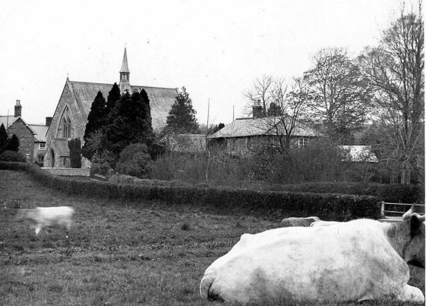
Thomas Burrough excommunicated; although he was a Deacon and Treasurer of the Chapel, he was buried in All Saints’ Church graveyard so he may have wished to be buried next to his father and decided to change his allegiance seventeen years before he died.
1876
Burial ground obtained; first grave in March.
1878
Old chapel completely renovated and reopened on 13th March.
1892
New organ presented by William Burrough.
1901
The Manse was built on a plot of land on the south side of High Lane given for a nominal ten shillings by Mrs Elizabeth Burrough (Abner’s widow) and her daughter Maria Louisa Witt in a Conveyance dated 25th April 1901 to the Trustees of the Congregational Church, on condition that the land would be used to build a house for the Minister. The building cost was £586.7s.10d plus some expenses.
A plaque on the wall of the Manse was unveiled on 10th July 1901.
Major contributors were Mr & Mrs Witt: £150, Mrs Abner Burrough: £110 and a building society loan: £100.
1972-1973
Scheme of Union: Congregational Church membership of United Reformed Church: letters January 1972; official confirmation 18/05/1973.
About 1995
Mr Goodfellow converted the existing lean-to vestry extension into a kitchen and extended it to form a cloakroom and toilets.
2006
Ian Chalk renovated the Chapel, installing a ramp for disabled access and modifying the interior forming two small rooms under the new balcony, laying carpet, replacing pews with chairs and other improvements.
2013
The conversion of part of the Chapel into a shop and post office commenced on 25th February 2013 and the opening date for business was on 3rd June 2013. The official opening by Sir Terry Pratchett took place on 22nd June 2013.
Congregational Church Ministers
Rev. Thomas Storey 1863 - 1869, Rev. S M Bell 1869 – 1874, Rev. G P Ring 1875 – 1880, Rev. C J P Farr 1881 – 1899, Rev. Samuel Thomas 1900 – 1908, Rev. W P Tucker 1908 – 1914, Rev. J Owen Jones 1915 – 1919, Rev. G Fellows 1922 – 1928, Rev. H S Kirkham 1929 – 1934, Rev. F M Varnon B.A. 1935 – 1944
Wilton, Broadchalke and Ebbesborne Group of Churches Ministers
Rev. J J Haynes B.D. 1945 – 1956, Rev. C A Hobson 1957 – 1960, Rev. P R Bending B.A. 1961 -

